Sermon for
Twenty–fifth Sunday after Pentecost

Date: November 11, 2018
Location: St. John’s Lutheran Church, Austin, MN
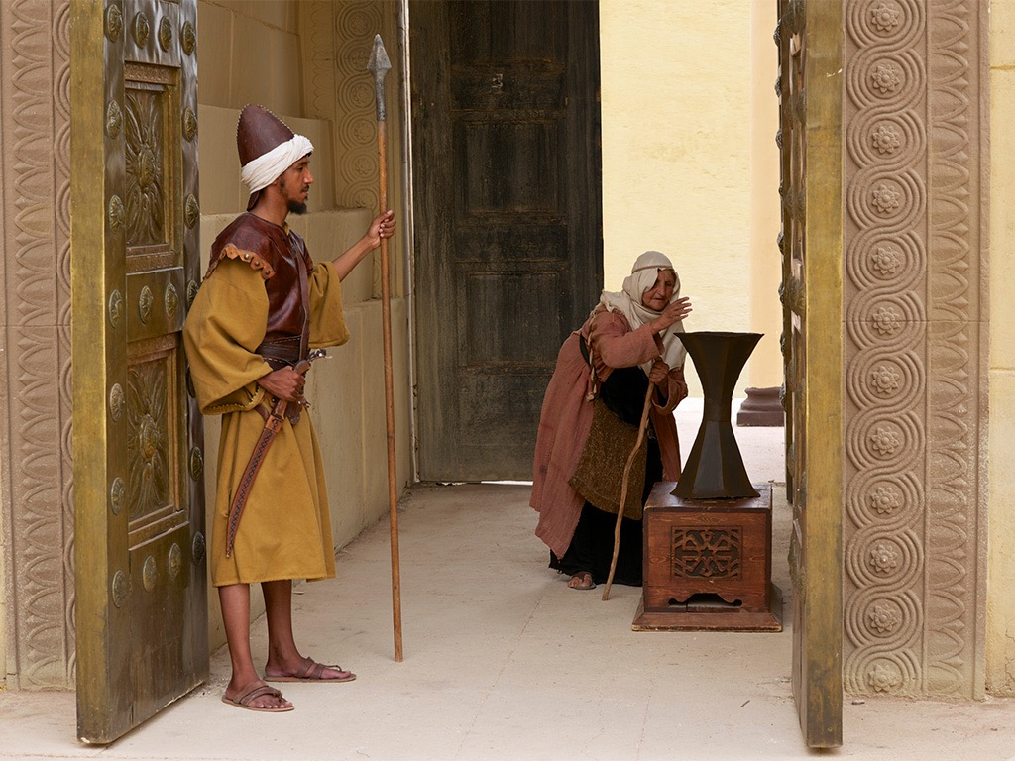
Old Testament: 1 Kings 17:8-16
Epistle Reading: Hebrews 9:24-28
Gospel Reading: Mark 12:38-44

Sermon Text: Mark 12:38-44
Sermon Title: Something Has Gone Very Wrong

Introit: Psalm 107:1-2, 41-42; Antiphon: Psalm 107:8

Hymns:
LSB 905 – Come Thou Almighty King
LSB 787 – The Temple Rang with Golden Coins
LSB 895 – Now Thank We All Our God (v.1-2)
LSB 733 – O God Our Help in Ages Past

Liturgy:
Divine Service III, p. 184


Pastor James Groleau
St. John’s Lutheran Church
1200 13th Avenue NW
Austin, MN 55912
Office: (507) 433-2642
Shepherd@JamesPlace.net
StJohnsAustinLCMS.org
FaceBook.com/StJohnsAustin
Twitter.com@StJohnsAustinMN
FaceBook.com/Shepherd.James.Groleau
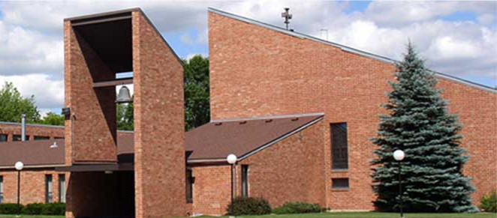
Text: Mark 12:38-44

As Jesus taught, he said, “Watch out for the experts in Moses’ Teachings! They like to walk around in long robes, to be greeted in the marketplaces, and to have the front seats in synagogues and the places of honor at dinners. They rob widows by taking their houses and then say long prayers to make themselves look good. The experts in Moses’ Teachings will receive the most severe punishment.”

As Jesus sat facing the Temple offering box, he watched how much money people put into it. Many rich people put in large amounts. A poor widow dropped in two small coins, worth less than a cent. He called his disciples and said to them, “I can guarantee this truth: This poor widow has given more than all the others. All of them have given what they could spare, but she, in her poverty, has given everything she had to live on.”

NOTE: Copyright information.
Bible Translation: GOD’S WORD®, © 1995 God’s Word to the Nations.

Credit for Images:

Pronunciation for difficult words are contained in { }

© 2018 James Groleau.
Permission is granted to use these sermons for any non-profit purpose. I only ask that credit, as to their origination, be noted appropriately.
.
Grace, and peace to you in Jesus’ Holy name. Amen.
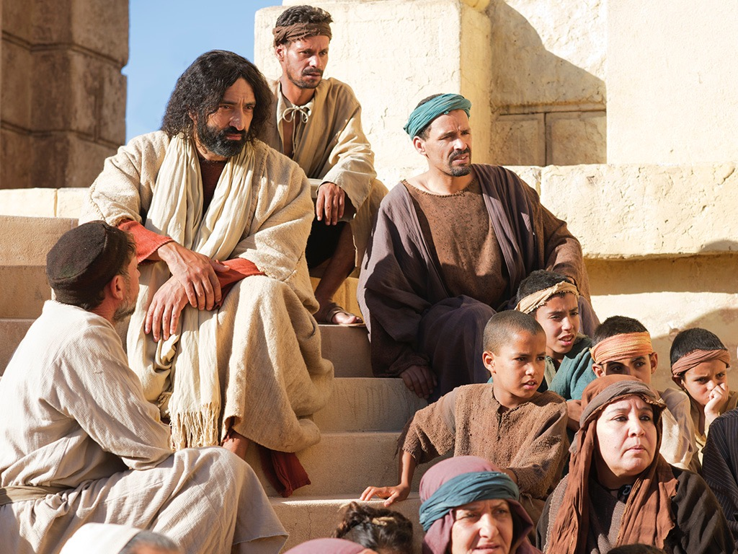
Jesus sat down and watched. You should always be careful when Jesus sits down to watch! You see He sees things that we can’t see. He sees things that, quite frankly, we sometimes don’t want to see. When Jesus sits down to watch you know that He’s about to teach you something deep. There’s something very important coming your way; something you should listen to and pay attention.
So this day, as Jesus sits in the Temple opposite the Temple Treasury, and watches people drop in their offerings it is actually quite a remarkable scene for three reasons:
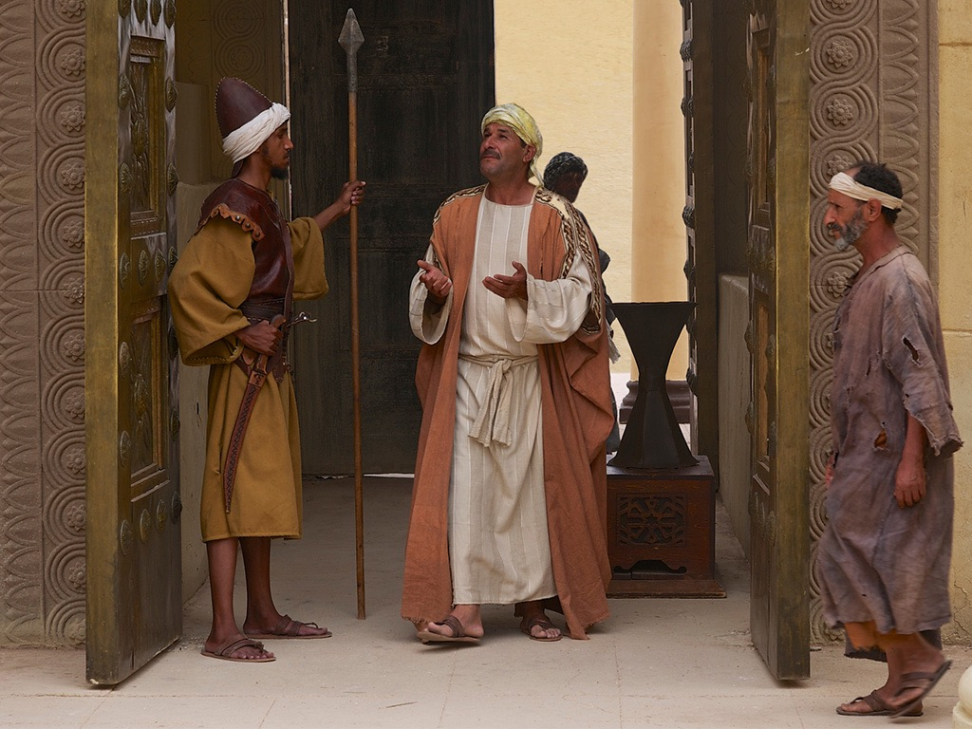
The first is that Jesus can watch this at all. You see this giving was supposed to be done in secret. It wasn’t supposed to be a public spectacle. That this event has somehow become more like a carnival parade for people to come and see, and be seen, is a sign that something has gone very wrong.

Second, it’s stunning that a poor widow is putting money into the Temple Treasury. This money was not meant for the upkeep of the Temple. This was not the general budget. This was money collected to take care of the poor, like this widow! The fact that she is contributing to the Temple Treasury is a sign that something has gone very wrong.
Third, it is amazing because the day on which Jesus does this is the Shrove Tuesday, or Tuesday of Holy Week. Just two days earlier He entered Jerusalem on a donkey to the shouts of Hosanna! Save us Lord! Just two days later He will celebrate the Passover meal with His disciples and during that meal will give to them the meal we call the Lord’s Supper. Then He will be arrested, and later the next morning He will be executed by crucifixion. Jesus knows all of that is coming. He knows what is waiting for Him at the end of this week and here He is on a Tuesday sitting down to watch. Sitting down to watch the offerings plinking into the pots.
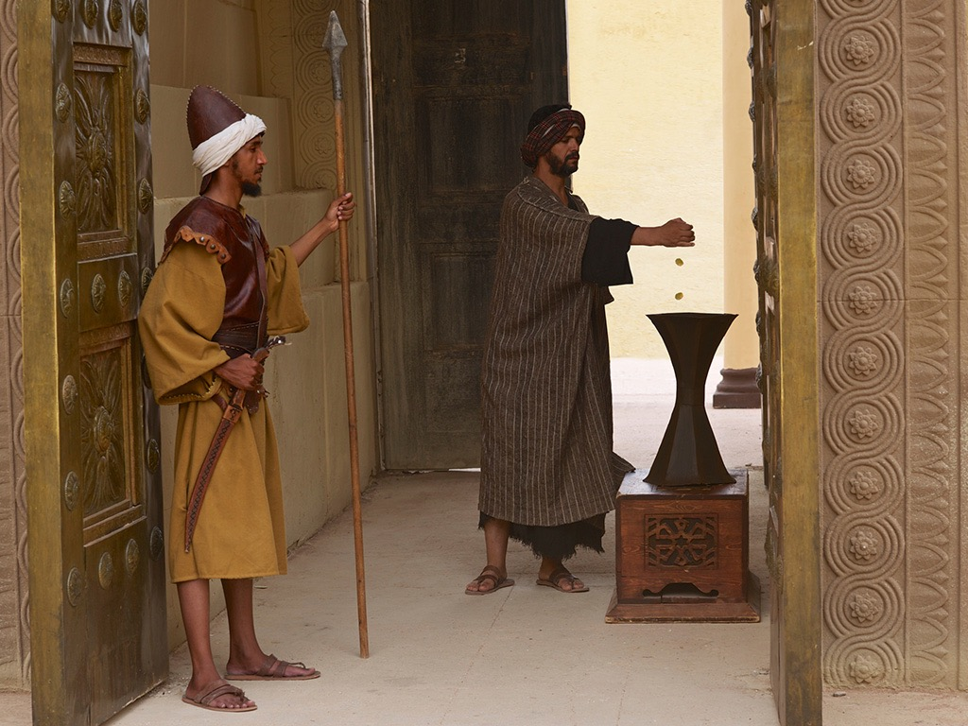
It makes you think. Who will sit and watch His offering when it is made? His offering which He gives to help the spiritually poor and broken; we poor miserable sinners. His offering is not made with copper, silver or gold. He fills Heaven’s Treasury with His holy precious body and blood and His innocent suffering and death. That is how He filled the coffers. Who will be watching when He makes His offering? Who will be watching when He gives all that He is and all that He has.
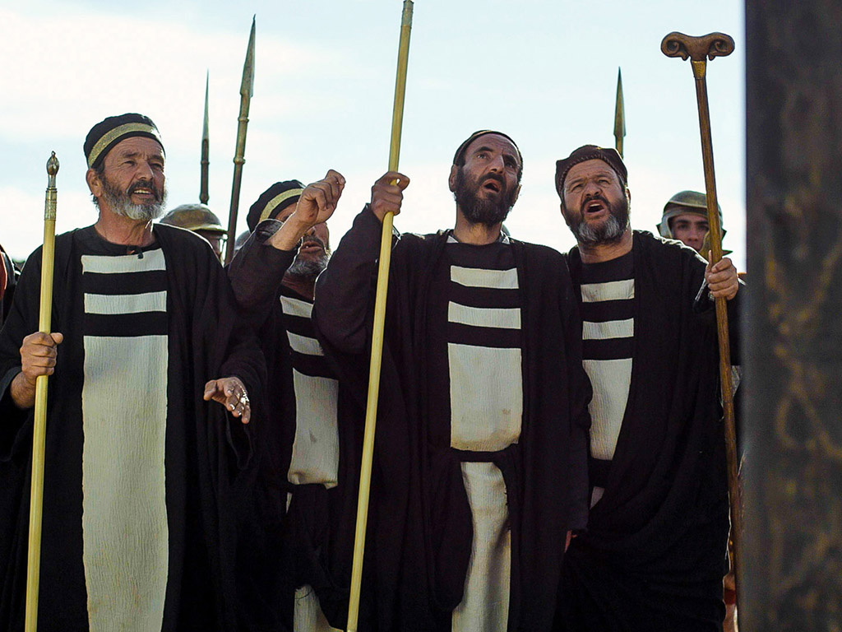
Not the Scribes and Pharisees. A few of them stuck around long enough to throw some insults at Him, but once they had Jesus on the cross they thought their work was done. They had more important things to do. Like foreclose widows houses.
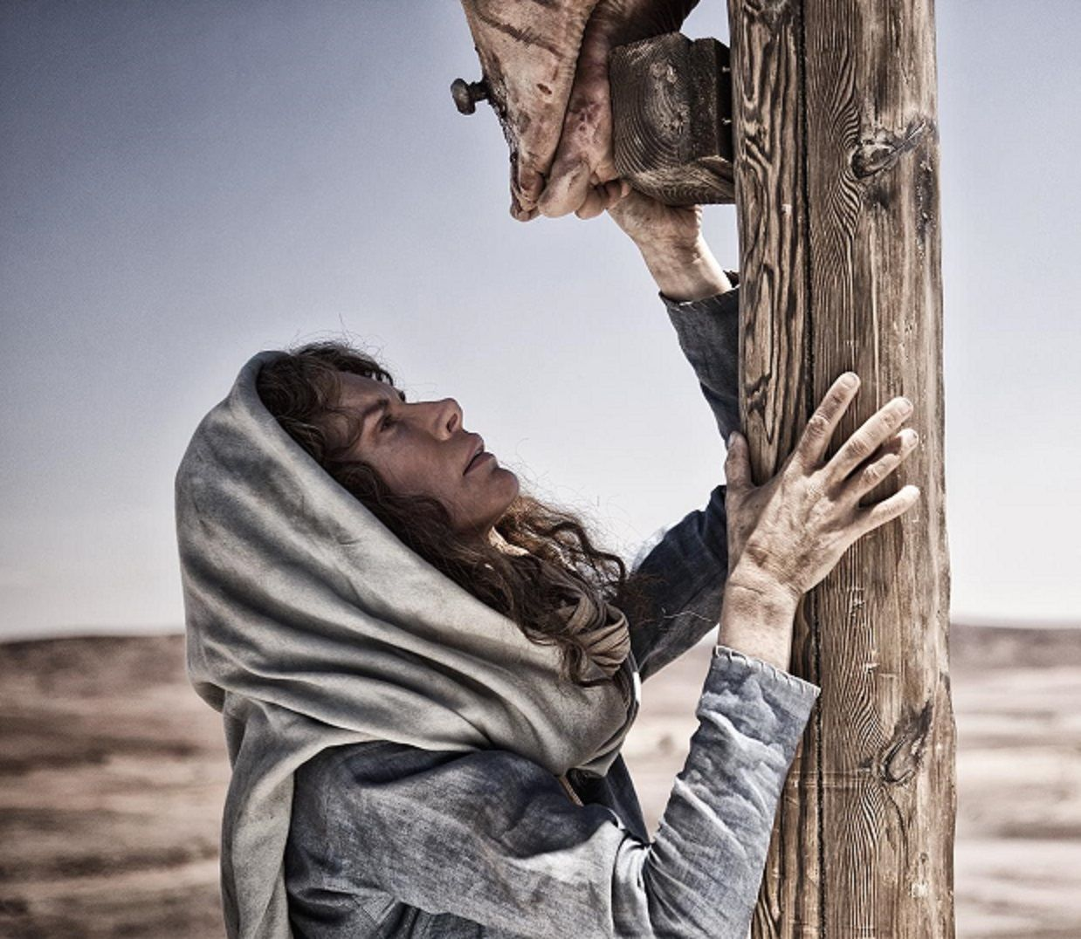
Not the disciples they all, all but John, ran away in fear. They didn’t stay to encourage and comfort their dear friend and teacher. Do you know who will be there? A poor widow. A widow named Mary. A sword of suffering piercing her heart in deep sorrow. When you see the perfect, holy, Son of God on the cross that is a sign that something has gone very wrong. It’s our sin that has made everything horribly wrong.
Understanding that is what makes this little, almost insignificant, recorded event much more than a stewardship lesson. Much more! If I stood up here and told you to give more, to give like this widow who gave all she had, and even gave you lots of pious sounding reasons to do it; if I pummeled you guilt until you emptied your pockets into the pan all I would be doing is making myself out to be a Scribe or Pharisee.
It has been said that guilt is profitable and that’s true, for a while. While you might, in fact for a time, give more you would be doing so for utterly wrong reasons. Though you might not strut around like a Scribal peacock, (and understand that some of them would have trumpets playing before them as they gave their offering so everyone could watch and see) though in your heart you might be most pleased with yourself for answering the call to give, for going above and beyond the call of duty, for putting on the show of a “good Christian…”; though all that might be true, there is another truth that should not be forgotten. When you are pleased with yourself before God, when you, as you kneel in humble submission before His throne, think highly of yourself, whether it is for what you give or for what you’ve done, or whatever else you think you are doing for God, or giving to God, like He needs anything from any of us, if you start thinking highly of yourself, that is a mighty dangerous place to be. If you feel God can’t get it done with out you something has gone very wrong.
The point of this little event, recorded for us to remember, is not that you are to be like this poor widow. The reason this event is recorded here, for us to remember, is to help us realize that you are the poor widow. No matter what you have in this world, be it a little or a lot, spiritually when you stand before the throne of God Most High you are the poor widow. You have nothing but debt before Him. You are spiritually bankrupt.
The perfect relationship between God and humankind in the Garden was destroyed by sin. Every sin is evidence of your rebellion against God. Every sin is evidence of you separation from God. Every sin is your testimony that God is not trustworthy or reliable. Every sin is a statement calling God a liar, rather than the Good Provider of what you need.
You sin to get what you think you need but your sin leaves you empty. Everything you gather or achieve in this world is all temporary. There has been a series on the History Channel® called, “The Men Who Built America.” It’s a good series. I enjoy it, but while I was writing this sermon it occurred to me. All of these powerful men of unimaginable wealth were all broke, impoverished.
No matter how much they managed to accumulate they always needed more. It was true for Vanderbilt, Rockefeller and Carnegie. It still true today for people like Bill Gate, Warren Buffett and George Soros, or pick your favorite rich guy. These men all had more money then the vast majority of countries in the world. Yet everyone of them felt like it just wasn’t enough. Why?!
Because deep down inside we all know it. Nothing here will last. Momentary riches and fleeting pleasures is all that sin ultimately offers. It’s really all that Satan has to offer you, and when he is done taking from you and using you, he leaves you in the ditch to rot and die, while he stands over you laughing. He leaves you, like a poor widow, with nothing.
That is the way of the world, and of our sin, and of our condition before God. That emptiness and hopeless condition would be our eternal reward, were it not for the One sitting there that day watching. Watching as the offerings where clinking into the coffers.
That One, who came to be our Savior to give Himself for us as an offering for our sin; to wash us clean and make us pure, pure as newly fallen snow on Christmas morning, that One is here. What a wonderful thing to learn that this One cares so deeply for us. It is even more wonderful to learn that this love is from the God we spurn by our sin. Though we left Him He has not left us. Instead has come to us, chases after us, and lays down His life for us.
The Lord God Most High sitting on His throne saw you running away. Now there is something about kings that you might know, though perhaps you’ve never really thought about it. Kings don’t run. Kings are the power. They do not have power, they are the power. When the king is running something has gone very wrong.
Yet our God and King, the train of His robe filling the Temple, our King who controls and maintains the entire universe, when He sees you running away, rises from His throne and commands that all keep silent. He has something important take care of, you! He does not rise in regal array with attendants attending. He jumps up from His throne and runs in desperation after you. The way a mother or father would run after their toddle who is running toward the busy street. There is panic on His face. Everything else is gone from His mind except that He must catch you! He must save you!
To know that you are cared for that much is wonderful. Yet as wonderful as that is to know it can also be troubling because we can’t understand it. Why would God do such a thing? Why would Jesus care about me? We look for something lovable in us. We can lie to others, we can put on a good show for others, but we can’t lie to ourselves. We know there’s nothing in us worthy of that kind of love. We look for something, anything, some good work, some difference, some reason, but there’s nothing to find. That might lead you to think it’s not for me, it can’t be for me, I’m just a poor, dirty, unworthy, sinful failure. God wouldn’t, couldn’t, do that for me.
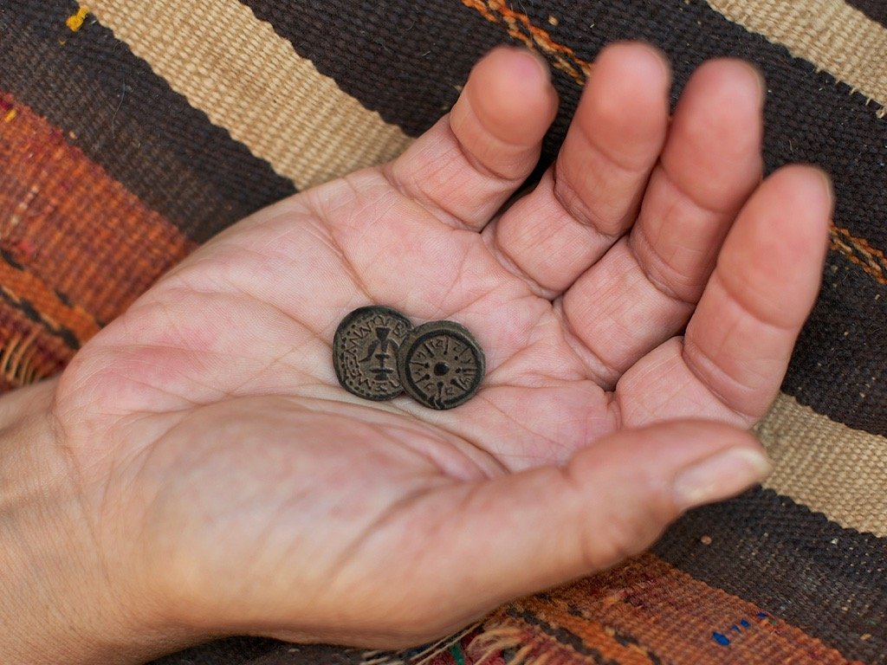
Remember the Temple Treasury into which the widow put her coins? Those offerings were meant to care for her, not to be taken from her. Things had been turned around. That’s what God does. He turns things around. The truth is Heaven’s Treasury, which Jesus filled with His holy precious body and blood, is for you.
It is for you who have nothing, for you who are worthless, for you who need the washing of forgiveness. Jesus did not come because you deserved it, but because He never stopped loving you. His love is the reason He came, which is why we can’t understand it. It is not of this world. It is extraterrestrial. It’s alien. It’s true! It’s real! As true and as real as His resurrection. As true and as real as His body and blood given here at this altar for you, so that you may be His own, and live under Him in His kingdom.
So while you may not have a seat of honor at the feasts and banquets in this world you do have a place of honor at the Holy Feast, Holy Communion. Here you come to the head table which is filled with a banquet that will never run out. His body and blood is here, each and every time you come back, the feast is here for you. The Holy, inerrant, Holy Spirit breathed, Word of your Lord is here for you each and every time you come back. The feast is here for you. His perfect forgiveness and absolution is here for you, each and every time you come back, the Feast is here for you.
To feast on His body and blood, to feast on His care and compassion, it is always here for you. Until we move from this table to the next, to the heavenly banquet table called that Marriage Feast of the Lamb. That feast that has no end.
Now the world cannot see all that is in this Supper. It sees a poor snack not worth much at all, but as Jesus sat in the Temple that day He saw what the world could not see. While the world saw a poor widow putting into the treasury nothing that would make a difference Jesus saw His Bride putting in all she had. Putting in all she had not because she had to but because she could. Not to win God’s love but because it was already hers. She shows who she is, and loves with the love that has been given to her. In the midst of all those who gave out of their abundance she shows herself to be the richest one of all. A child of God.
You may be someone in this world or no one. You may be rich or poor. You may be loved or despised. You may be useful or useless. Jesus sees in you what the world cannot see. He has come. For you He has set His body and blood on this altar. To give you what you do not have, to cleanse you and to call you to Himself once again. Each time His holy body is placed into your mouth and each time His holy blood is poured over your lips, you hear and see His loving self-sacrifice. Each time. Every time. His love, His feast, His forgiveness never running out.
… and you know what? That makes you, among this world of abundance, the richest ones of all. Rich in faith. Rich in hope. Rich in salvation that cannot be taken away. You are a holy child of God, now and forever.
Amen.

‘Shrove’ is a very old English word that means ‘confess.’ An old tradition was to go to church on Shrove Tuesday to confess your sins in preparation for Ash Wednesday.
Holy Week is the week before Easter.
Hosanna is a Hebrew word that means: ’Save us Lord.’
Mark 12:40
Luke 2:35
Isaiah 6:1
Luther’s Small Catechism: Explanation to the Second article of the Apostles’ Creed.
The Church is often called “The Bride of Christ.”
Matthew 6:19-21
John 10:28-30

